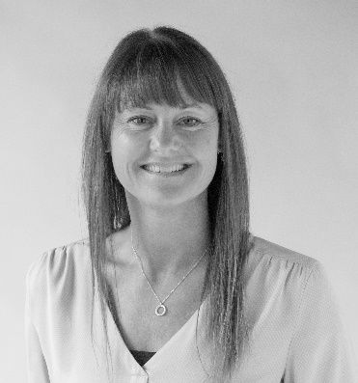
Marianne Holch
Project Lead
VIA Design and Business / VIA University College
DENMARK
mari@via.dk
+45 87550549

It’s difficult to get to know each other when we are online, where random meetings over coffee don’t occur.
Please indicate your strengths (as short bullets) to the left: your key competences and/or what you can “offer” this group of people – what are you “selling” ?
And to the right please indicate what you would like more knowledge about at this conference, what are you curious about or what would you like help/sparring with on – what are you “buying” (as short bullets)?

SELLING  (Your strengths/competences) | BUYING  (I’m curious about….)
<Please enter here> | <Please enter here>
<Please enter here> | <Please enter here>
<Please enter here> | <Please enter here>
<Please enter here> | <Please enter here>
<Please enter here> | <Please enter here>

