E&PDE2012 CONFERENCE
Design education for future wellbeing

JOINING DETAILS

VISIT TO MASS
Wednesday, 5 September 2012

The MAS is an impressive building with a museum, among other things. Because it is also the visible storage, the museum square with Luc Tuymans’ mosaic, the boulevard, the rooftop panorama, etc. The MAS is a total experience.
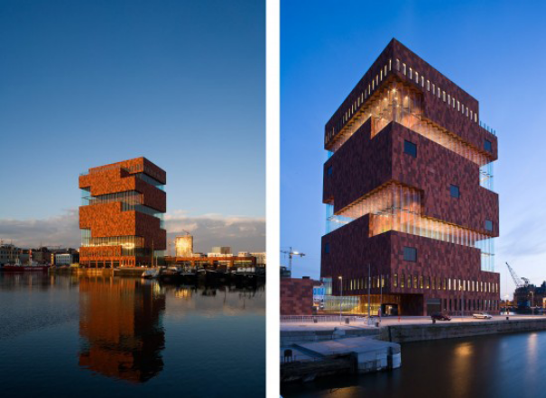

The MAS floor by floor
3 Masterpieces. Five centuries of the image (From 17 May 2011 through 30 December 2012)
The opening exhibition confronts masterpieces by the old masters with works by contemporary artists. Through famous works from the Antwerp collections, Masterpieces in the MAS | Five centuries of the image in Antwerp displays the evolution of visual culture from the Middle Ages to the present day.

4 Display of Power. On prestige and symbols
Beautiful, often sacred, status symbols play an important role in displays of power within all cultures. The MAS collection houses thousands of these status symbols from all over the world.

5 Metropolis. On here and elsewhere
How has Antwerp portrayed itself over the past 500 years? In short, as a city with many faces, but also time and again as a city by the river and as a city of the world. A city lives in the present, is built on its past, and looks out towards the future. It takes shape through buildings and events, and in portraits and stories.

6 World port. On trade and shipping
The visitor discovers how much Antwerp owes to its port on the River Scheldt. The story begins with the port as a small medieval settlement. With its ups and downs, it has continued to expand, to become one of the largest ports of the world.

7 & 8 Life and death. On the upper- and underworld
Floor 8 demonstrates what it means to live in close contact with nature. In nature-centered religions all over the world, ancestors and spirits play an important role. They live in invisible worlds above and below us. This is intriguingly illustrated by the superb collection of pre-Columbian art of Paul and Dora Janssen-Arts.
A trip to MAS will be arranged for at 1430 (gathering at Conference Hub) / 1500 (gathering at MAS entrance hall). Please indicate at the time of registering whether you would like to join a group of delegates for this visit. Remember, the group is limited to 20 delegates who will be able to have a free Quick Tour. This tour will last about an hour and a half.

EARLY REGISTRATION
Wednesday, 5 September 2012
Delegates have the opportunity of registering the evening before the conference from 1800 – 2000 at Artesis University College (map: http://g.co/maps/dga2s). A selection of Belgium beers and cheeses will be available for you to enjoy. A student ambassador will be at the entrance and will direct you accordingly.

REGISTRATION
Thursday, 6 September 2012
The Conference will take place at Artesis University College (map: http://g.co/maps/dga2s) and you can register from 0830. A student ambassador will be at the entrance to direct you. There is a safe cloakroom. The Keynote Presentations will begin at 9am after the Welcome address.

SOCIAL EVENT AND CONFERENCE DINNER
Before the Conference Dinner on 6th September, delegates have been invited by Patrick Janssens (Mayor) and Robert Voorhamme (Alderman for Education and Economy) to attend a drinks reception at the Wandelzaal (City Hall) hosted by the City Council. Student Ambassadors will guide delegates to the City Hall for 1730.

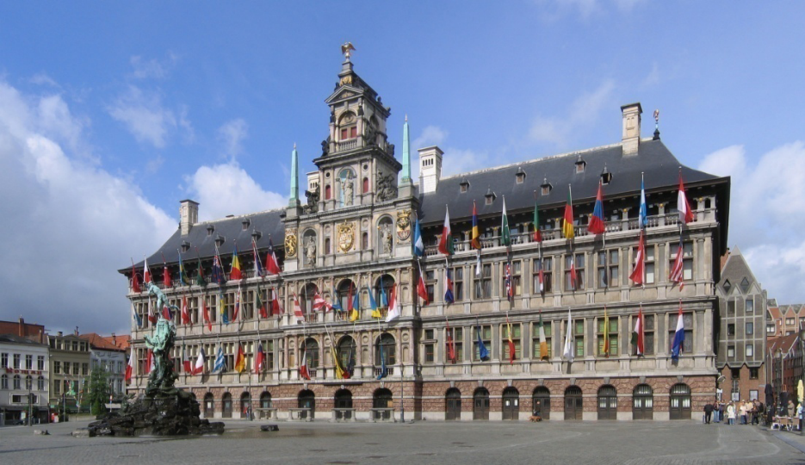

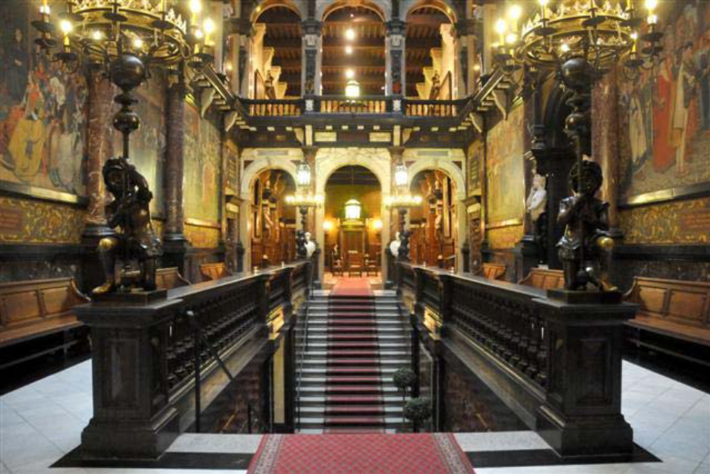

At 1830 delegates will be guided to the Grand Café, Art Nouveau Zaal (Hopland 2, Quartier Latin, Antwerp) - the Conference Dinner venue - to experience Belgian gastronomy at its best.

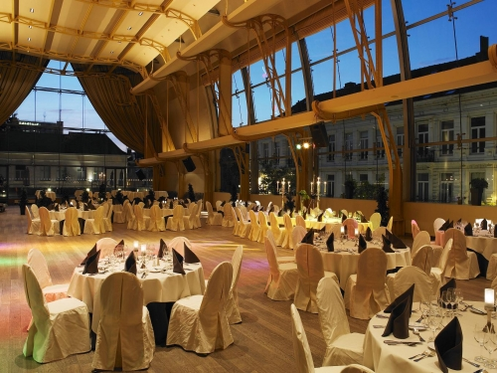

SUMMARY
Optional
Visit to MAS on the afternoon of Wednesday, 5 September 2012 at 1500

Optional
Early Registration - Wednesday, 5 September 2012 from 1800-2000.

Registration
Thursday, 6 September 2012 from 0830

Social Event
Wandelzaal (City Hall) hosted by the City Council from 1730-1830

Conference Dinner
Grand Café – 1900

Refreshments will be provided twice in the morning and twice in the afternoon. However some soft drinks will be available throughout the day. You may purchase a drink from the machine in the canteen.

A secure cloakroom will be provided free of charge.

Lunch for two days is included in price

Conference Dinner is included in the price.

We look forward to seeing
you in Antwerp!

